Headers & Metadata

🧾 What Are Headers & Metadata?
# Source: AI Source: Provided by: [Data Path: Persons Table -> ID Column: 1, Name_En Column: Motasem Essam] -> From: [ChatGPT] on [2/12/2026]
Headers are extra information sent with HTTP requests and responses to give context about the data being transferred.
👉 They do NOT contain the main data — they describe it.

✅ Simple Definition:
# Source: AI Source: Provided by: [Data Path: Persons Table -> ID Column: 1, Name_En Column: Motasem Essam] -> From: [ChatGPT] on [2/12/2026]
Headers are key-value pairs that provide additional information (metadata) about a request or response.

🧠 Real-Life Analogy:
# Source: AI Source: Provided by: [Data Path: Persons Table -> ID Column: 1, Name_En Column: Motasem Essam] -> From: [ChatGPT] on [2/12/2026]
Think of headers like the label on a package 📦:
● Package content → actual data
● Label → metadata (headers)
👉 The label tells:
- where it’s from
- how to handle it
- who can open it

🔁 How Headers Work
# Source: AI Source: Provided by: [Data Path: Persons Table -> ID Column: 1, Name_En Column: Motasem Essam] -> From: [ChatGPT] on [2/12/2026]
- 👤 Client sends a request
- 🧾 Headers are included with the request
- ⚙️ Server reads headers
- 📥 Server responds with its own headers
- 🖥️ Client uses headers to understand the response

📤 Example HTTP Request with Headers
# Source: AI Source: Provided by: [Data Path: Persons Table -> ID Column: 1, Name_En Column: Motasem Essam] -> From: [ChatGPT] on [2/12/2026]
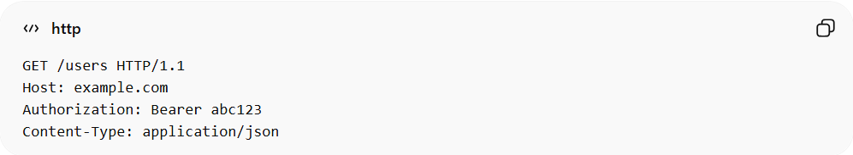
GET /users HTTP/1.1
Host: example.com
Authorization: Bearer abc123
Content-Type: application/json
● Authorization → token for authentication
● Content-Type → format of data
● Host → server address

📥 Example HTTP Response with Headers
# Source: AI Source: Provided by: [Data Path: Persons Table -> ID Column: 1, Name_En Column: Motasem Essam] -> From: [ChatGPT] on [2/12/2026]
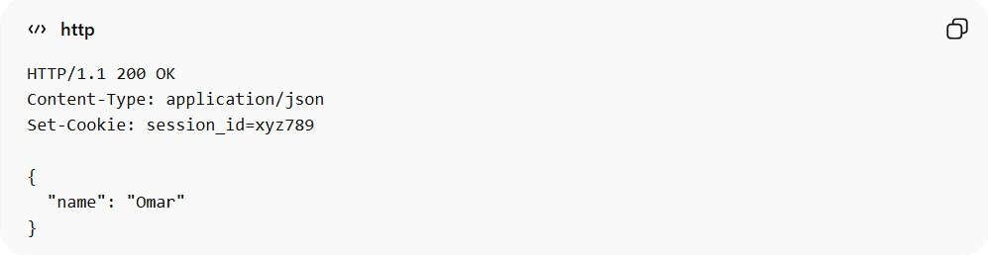
HTTP/1.1 200 OK
Content-Type: application/json
Set-Cookie: session_id=xyz789

{
"name": "Omar"
}
● Content-Type → response format
● Set-Cookie → stores data in browser

📊 Common Headers

🔹 1. Content-Type
# Source: AI Source: Provided by: [Data Path: Persons Table -> ID Column: 1, Name_En Column: Motasem Essam] -> From: [ChatGPT] on [2/12/2026]
Defines the format of data:
● application/json
● text/html
● application/xml

🔹 2. Authorization
# Source: AI Source: Provided by: [Data Path: Persons Table -> ID Column: 1, Name_En Column: Motasem Essam] -> From: [ChatGPT] on [2/12/2026]
Used for authentication:
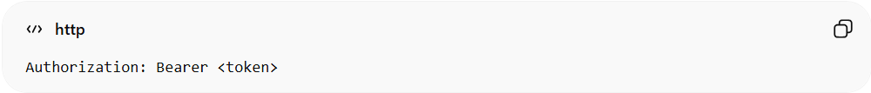
Authorization: Bearer <token>

🔹 3. Cookie
# Source: AI Source: Provided by: [Data Path: Persons Table -> ID Column: 1, Name_En Column: Motasem Essam] -> From: [ChatGPT] on [2/12/2026]
Sends stored cookies:
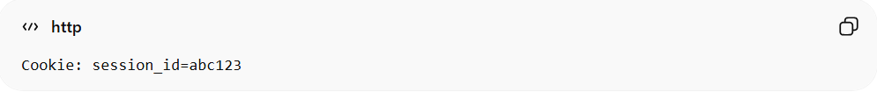
Cookie: session_id=abc123

🔹 4. Set-Cookie
# Source: AI Source: Provided by: [Data Path: Persons Table -> ID Column: 1, Name_En Column: Motasem Essam] -> From: [ChatGPT] on [2/12/2026]
Server sends cookies to browser:
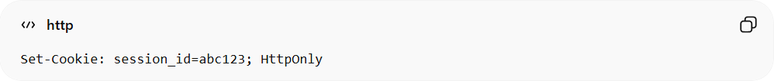
Set-Cookie: session_id=abc123; HttpOnly

🔹 5. Accept
# Source: AI Source: Provided by: [Data Path: Persons Table -> ID Column: 1, Name_En Column: Motasem Essam] -> From: [ChatGPT] on [2/12/2026]
Defines what response formats the client accepts:
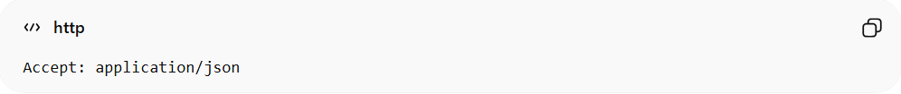
Accept: application/json

📦 What Is Metadata?
# Source: AI Source: Provided by: [Data Path: Persons Table -> ID Column: 1, Name_En Column: Motasem Essam] -> From: [ChatGPT] on [2/12/2026]
Metadata = data about data
👉 Headers are metadata because they describe:
- the request
- the response
- the data format
- authentication

🔗 Relation to Other Topics
# Source: AI Source: Provided by: [Data Path: Persons Table -> ID Column: 1, Name_En Column: Motasem Essam] -> From: [ChatGPT] on [2/12/2026]
● HTTP → uses headers in requests/responses
● APIs → rely on headers for communication
● Tokens → sent inside Authorization header
● Cookies → stored and sent via headers

💻 Simple PHP Example
# Source: AI Source: Provided by: [Data Path: Persons Table -> ID Column: 1, Name_En Column: Motasem Essam] -> From: [ChatGPT] on [2/12/2026]
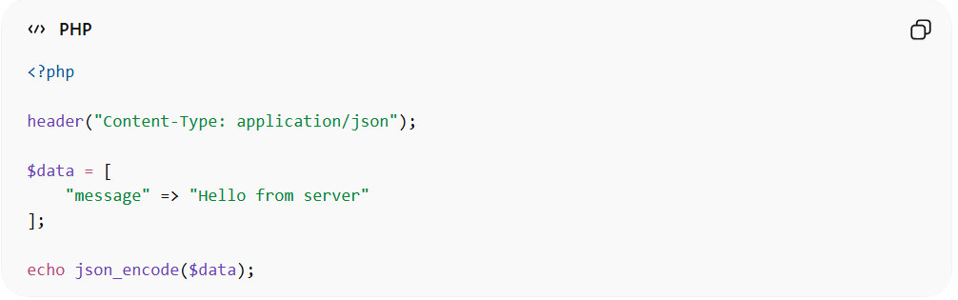
<?php

header("Content-Type: application/json");

$data = [
"message" => "Hello from server"
];

echo json_encode($data);
● header() sets response headers
● Tells browser that response is JSON

🎯 Key Idea
# Source: AI Source: Provided by: [Data Path: Persons Table -> ID Column: 1, Name_En Column: Motasem Essam] -> From: [ChatGPT] on [2/12/2026]
👉 Headers = extra information about the data
👉 Metadata = data about data

🎓 Final Mental Model
# Source: AI Source: Provided by: [Data Path: Persons Table -> ID Column: 1, Name_En Column: Motasem Essam] -> From: [ChatGPT] on [2/12/2026]
● Data = actual content
● Headers = instructions about the data
👉 Without headers → communication becomes unclear

🔥 Simple Summary
# Source: AI Source: Provided by: [Data Path: Persons Table -> ID Column: 1, Name_En Column: Motasem Essam] -> From: [ChatGPT] on [2/12/2026]
● Headers = metadata of HTTP
● Used for:
- authentication
- content type
- cookies
- security
👉 They are essential for secure and structured communication

